Guidance for Topic 5 DQ 2
- As always, first enter your name. Then, the data show up.

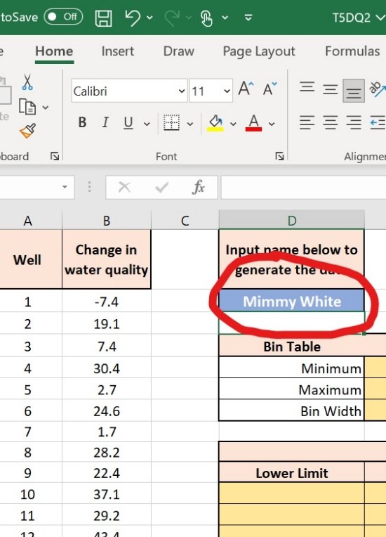

- To find the min, use =MIN(B2:B103)-0.1. For the max, use =MAX(B2:B103)+0.1. These adjustments by 0.1 ensure that the minimum and the maximum values are included in the frequency table. For the bin width, use =(E6-E5)/11. We divide E6-E5 by 11, which is the number of intervals in the frequency distribution table.

- In D11, enter =E5. In E11, enter =D11+$E$7. Note $E$7 is the bin width.

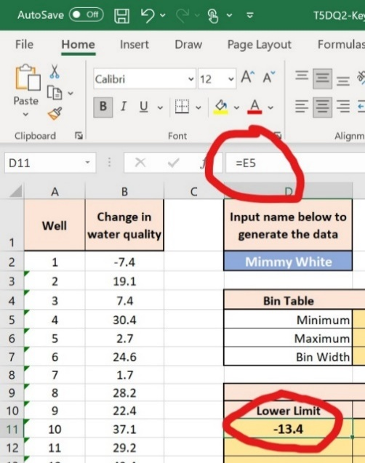
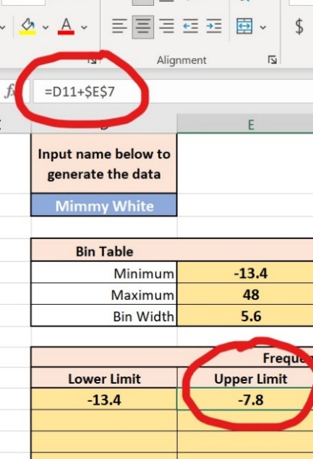

- Next, enter =E11 in D12 and drag down the formula. (You just copy the high end of the previous bin to the low end of the next.)

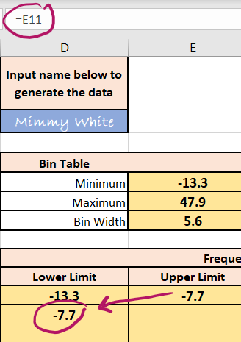

- Drag down E11 to E12. Then drag (or cut-paste) D12:E12 on down.
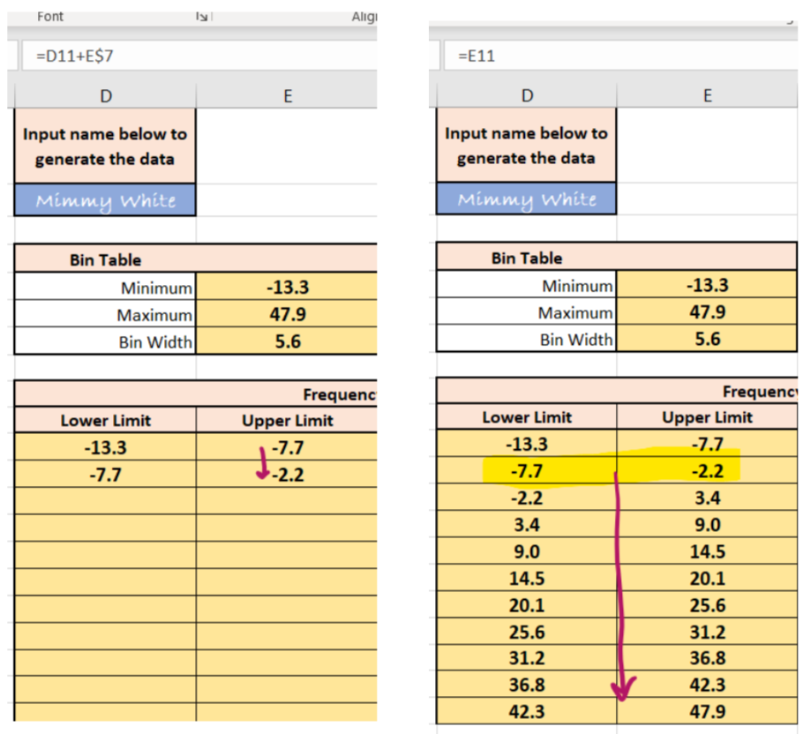

- The title of the bin has to be the midpoint of the lower and upper limits. Enter the formula in F11 as shown, and drag down the formula.

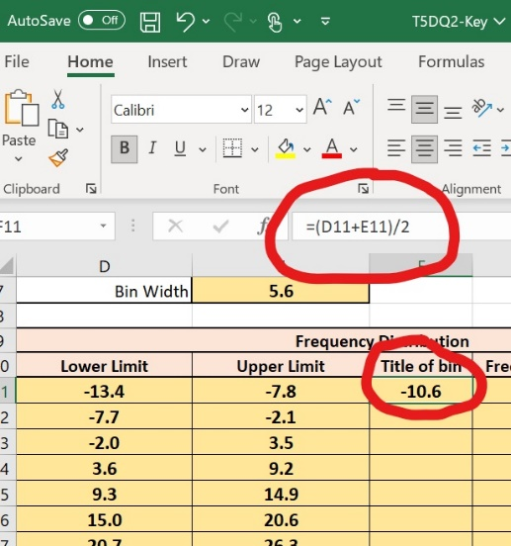

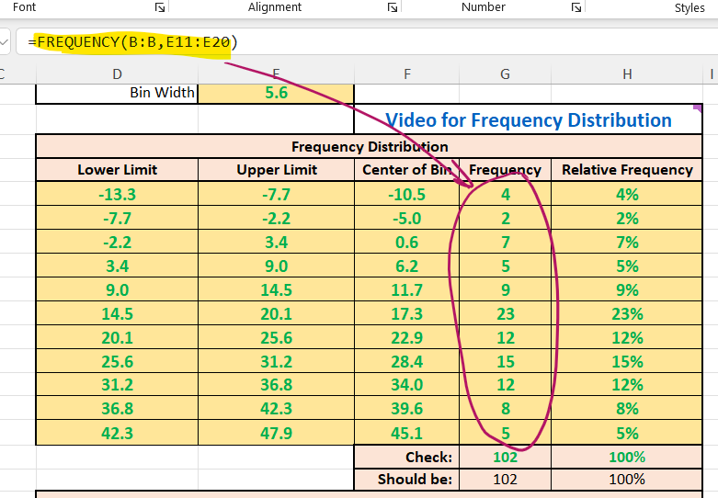
- Now, you need to fill out the frequency column. The simplest thing to use here is the =FREQUENCY() function. In this case, =FREQUENCY(B:B, E11:E19) is what you want.

There is a video link in the DQ that is made specifically for this class. (I won’t put the link here as it might change.)The relative frequency is = frequency/(number of data points). There are 102 wells, i.e., data points. This formula works in H11: =G11/SUM(G$11:G$20) and then use autofill. Depending on how you computed the frequency you might be able to use =G11#/SUM(G11#) in H11 and this will fill out the entire column.
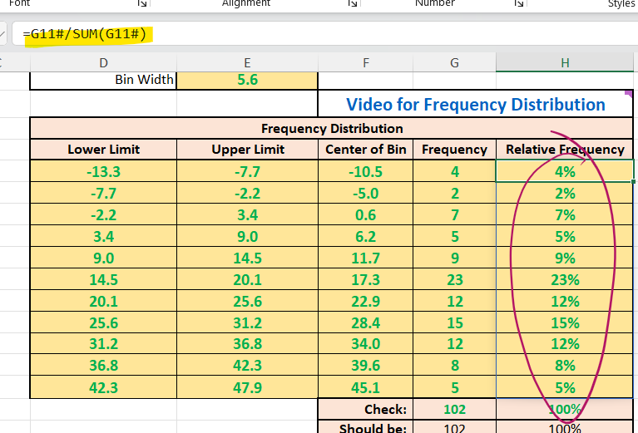

- How to create a histogram is very similar to how to create a pie chart, which is explained in topic 4 DQ 1.

There are some important details: (1) a histogram must not have breaks or gaps between bars, and (2) The “x-axis” needs the correct labels; the data is a continuous numeric variable, and the correct values need to be labeled. Here, you should use the “Title of bin” data that you have already computed. For these two reasons, the following is not a histogram.
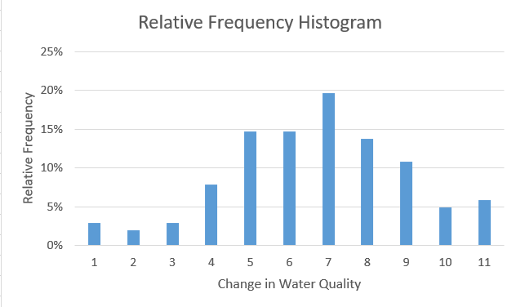

A correct minimalistic histogram would be the following:
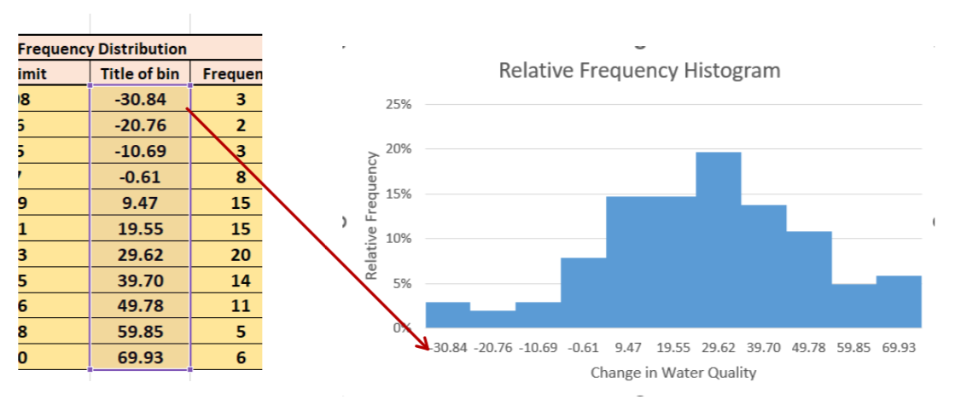

This is also discussed in the video provided in the DQ.

